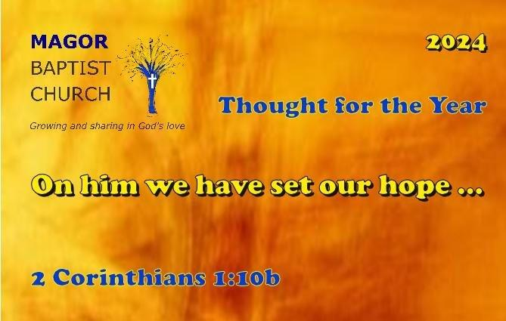
Welcome

We are delighted that you are here today.

After the service, please enjoy tea or coffee and a chat.

Useful Information
The hymns and service details are displayed on the screen.
Visiting children are invited to join with the Sunday club.
A Sunday club leader will greet you.
Offerings can be placed in the plate on the left inside the church.
The offering is blessed during the service.
Communion is normally on the first Sunday of the month.
The bread we use is gluten free and the wine is alcohol free.
Bibles are available at the door.

Background
This church was founded over 200 years ago using the name Ebenezer, that means ’Thus far the Lord has helped us;’ in the hope and knowledge that God would continue to help us in the future. We have always been open to all regardless of where they live even though today, we now refer to the building and the fellowship as Magor Baptist Church.
Activities held at the Church
Weekly
Sunday | Morning Service and Sunday Club | 11am
Monday | Morning Toddler Group | 9.00am-11am
 | Afternoon Knit and Natter | 1.30pm-3pm
 | Prayer Meeting | 7.30pm
Wednesday | Morning House Group | 10.30am
Thursday | Superheroes, after school club | 3.30pm-4.30pm
Friday | Coffee Morning | 10am-12pm.
 | Morning House Group | 11am-12pm

Activities held in members’ homes
Wednesday Afternoon House Group at 2pm contact Val Jones
Wednesday Evening House Group at 7.30pm contact Andrew Leighton

Prayer
Monday evening at 7.30pm
The occasional Saturday Prayer Breakfast is at 8.30am

Monthly Activities
1st Monday of the Month Light Lunch 12pm
Contact Chris Foster

Solo diners meet for Sunday lunch once a month
Contact Gaynor Chapple

1st Saturday of the month Open Door Men’s group 10am
Contact John Loebl

2nd Tuesday of the Month Ladies Friendship 7.30pm
Contact Jenny Tilton

2nd Saturday of the month
Children’s music sessions
10.00am to 12 pm.
Age group: juniors
Contact Jo Fenton

Church Contacts
Minister: Rev Mark Thomas Tel: 07530 055440
Email: markinmagor@gmail.com

Church Secretary: Kathy Allen Tel: 07724174493
Email: enquires@magorbaptistchurch.org.uk
Treasurer: John Loebl Tel: 01633 880318
Email: jloebl@hotmail.co.uk
Safeguarding Designated Person: Kathy Allen Tel: 07724174493
Magazine Editor: John Loebl Tel: 01633 880318
Email: jloebl@hotmail.co.uk
Church Lettings: Christine Miles Tel: 01633 882316
Email: bookings@magorbaptistchurch.org.uk
House group co-ordinator: Ann Nias Tel 01633 880619
Email ann_nias@yahoo.co.uk
Children’s Music: Jo Fenton jofenton17@gmail.com

More details and news see the website or Facebook page
Particularly about our occasional afternoon and evening services.
https://www.magorbaptistchurch.org.uk/

